广州工商学院2019-2020学年度第一学期
期中考试试卷（机试）
考试科目：[106010006]高级交换与路由 |  |  |  |  |  | 试卷类型：A卷
专 业：17网络工程 |  |  |  |  |  | 考核类型：考试
考试时间：90分钟 |  |  |  |  |  | 考试形式：闭卷
姓名 | 麦嘉鑫 | 学号 | 201702250340 | 专业 | 网络工程 |  | 班级 | B3

题号 | 一 | 二 | 三 | 四 | 五 | 六 |  | 总分
分值 | 50 | 50 |  |  |  |  |  | 100
得分
一、交换机的配置（每题50分，共50分）
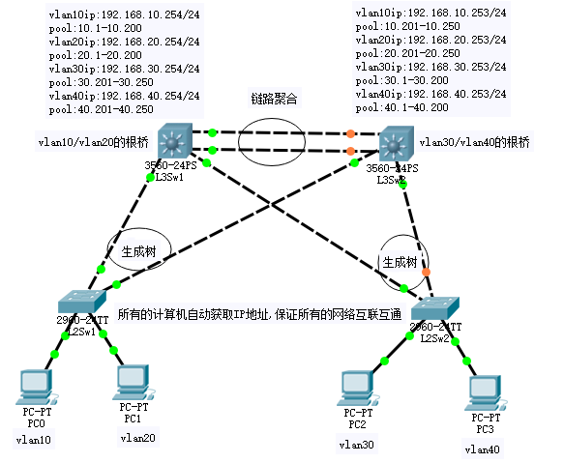
1、根据下面网络拓扑图，完成设备的配置。

评分标准：
（1）网络设备连接正确，5分；
（2）标识正确，5分；
（3）地址正确，5分；
（4）VLAN划分正确，5分；
（5）链路聚合配置正确，10分；
（6）生成树配置正确，10分；
（7）DHCP服务配置正确，10分

S1:
#
sysname S1
#
undo info-center enable
#
vlan batch 10 20 30 40
#
stp instance 1 root primary
stp instance 2 root secondary
#
cluster enable
ntdp enable
ndp enable
#
drop illegal-mac alarm
#
dhcp enable
stp region-configuration
instance 1 vlan 10 to 20
instance 2 vlan 30 to 40
active region-configuration
#
drop-profile default
#
ip pool vlan10
gateway-list 192.168.10.254
network 192.168.10.0 mask 255.255.255.0
excluded-ip-address 192.168.10.201 192.168.10.250
#
ip pool vlan20
gateway-list 192.168.20.254
network 192.168.20.0 mask 255.255.255.0
excluded-ip-address 192.168.20.201 192.168.20.250
#
ip pool vlan30
gateway-list 192.168.30.254
network 192.168.30.0 mask 255.255.255.0
excluded-ip-address 192.168.30.1 192.168.30.200
#
ip pool vlan40
gateway-list 192.168.40.254
network 192.168.40.0 mask 255.255.255.0
excluded-ip-address 192.168.40.1 192.168.40.200
#
aaa
authentication-scheme default
authorization-scheme default
accounting-scheme default
domain default
domain default_admin
local-user admin password simple admin
local-user admin service-type http
#
interface Vlanif1
#
interface Vlanif10
ip address 192.168.10.254 255.255.255.0
dhcp select global
#
interface Vlanif20
ip address 192.168.20.254 255.255.255.0
dhcp select global
#
interface Vlanif30
ip address 192.168.30.254 255.255.255.0
dhcp select global
#
interface Vlanif40
ip address 192.168.40.254 255.255.255.0
dhcp select global
#
interface MEth0/0/1
#
interface Eth-Trunk12
port link-type trunk
port trunk allow-pass vlan 2 to 4094
#
interface GigabitEthernet0/0/1
port link-type trunk
port trunk allow-pass vlan 2 to 4094
#
interface GigabitEthernet0/0/2
port link-type trunk
port trunk allow-pass vlan 2 to 4094
#
interface GigabitEthernet0/0/3
eth-trunk 12
#
interface GigabitEthernet0/0/4
eth-trunk 12
#

S2:
#
sysname S2
#
undo info-center enable
#
vlan batch 10 20 30 40
#
stp instance 1 root primary
stp instance 2 root secondary
#
cluster enable
ntdp enable
ndp enable
#
drop illegal-mac alarm
#
dhcp enable
#
diffserv domain default
#
stp region-configuration
instance 1 vlan 30 to 40
instance 2 vlan 10 to 20
active region-configuration
#
drop-profile default
#
ip pool vlan10
gateway-list 192.168.10.253
network 192.168.10.0 mask 255.255.255.0
excluded-ip-address 192.168.10.1 192.168.10.200
#
ip pool vlan20
gateway-list 192.168.20.253
network 192.168.20.0 mask 255.255.255.0
excluded-ip-address 192.168.20.1 192.168.20.200
#
ip pool vlan30
gateway-list 192.168.30.253
network 192.168.30.0 mask 255.255.255.0
excluded-ip-address 192.168.30.201 192.168.30.250
#
ip pool vlan40
gateway-list 192.168.40.253
network 192.168.40.0 mask 255.255.255.0
excluded-ip-address 192.168.40.201 192.168.40.250
#
aaa
authentication-scheme default
authorization-scheme default
accounting-scheme default
domain default
domain default_admin
local-user admin password simple admin
local-user admin service-type http
#
interface Vlanif1
#
interface Vlanif10
ip address 192.168.10.253 255.255.255.0
dhcp select global
#
interface Vlanif20
ip address 192.168.20.253 255.255.255.0
dhcp select global
#
interface Vlanif30
ip address 192.168.30.253 255.255.255.0
dhcp select global
#
interface Vlanif40
ip address 192.168.40.253 255.255.255.0
dhcp select global
#
interface MEth0/0/1
#
interface Eth-Trunk12
port link-type trunk
port trunk allow-pass vlan 2 to 4094
#
interface GigabitEthernet0/0/1
port link-type trunk
port trunk allow-pass vlan 2 to 4094
#
interface GigabitEthernet0/0/2
port link-type trunk
port trunk allow-pass vlan 2 to 4094
#
interface GigabitEthernet0/0/3
eth-trunk 12
#
interface GigabitEthernet0/0/4
eth-trunk 12
#

S3:
#
sysname S3
#
undo info-center enable
#
vlan batch 10 20 30 40
#
cluster enable
ntdp enable
ndp enable
#
drop illegal-mac alarm
#
diffserv domain default
#
drop-profile default
#
aaa
authentication-scheme default
authorization-scheme default
accounting-scheme default
domain default
domain default_admin
local-user admin password simple admin
local-user admin service-type http
#
interface Vlanif1
#
interface MEth0/0/1
#
interface Ethernet0/0/1
port link-type trunk
port trunk allow-pass vlan 2 to 4094
#
interface Ethernet0/0/2
port link-type trunk
port trunk allow-pass vlan 2 to 4094
#
interface Ethernet0/0/3
port link-type access
port default vlan 10
#
interface Ethernet0/0/4
port link-type access
port default vlan 10
#
interface Ethernet0/0/5
port link-type access
port default vlan 10
#
interface Ethernet0/0/6
port link-type access
port default vlan 10
#
interface Ethernet0/0/7
port link-type access
port default vlan 10
#
interface Ethernet0/0/8
port link-type access
port default vlan 10
#
interface Ethernet0/0/9
port link-type access
port default vlan 10
#
interface Ethernet0/0/10
port link-type access
port default vlan 10
#
interface Ethernet0/0/11
port link-type access
port default vlan 10
#
interface Ethernet0/0/12
port link-type access
port default vlan 10
#
interface Ethernet0/0/13
port link-type access
port default vlan 10
#
interface Ethernet0/0/14
port link-type access
port default vlan 20
#
interface Ethernet0/0/15
port link-type access
port default vlan 20
#
interface Ethernet0/0/16
port link-type access
port default vlan 20
#
interface Ethernet0/0/17
port link-type access
port default vlan 20
#
interface Ethernet0/0/18
port link-type access
port default vlan 20
#
interface Ethernet0/0/19
port link-type access
port default vlan 20
#
interface Ethernet0/0/20
port link-type access
port default vlan 20
#
interface Ethernet0/0/21
port link-type access
port default vlan 20
#
interface Ethernet0/0/22
port link-type access
port default vlan 20
#
interface GigabitEthernet0/0/1
#
interface GigabitEthernet0/0/2
#
interface NULL0
#

S4:
#
sysname S4
#
undo info-center enable
#
vlan batch 10 20 30 40
#
cluster enable
ntdp enable
ndp enable
#
drop illegal-mac alarm
#
diffserv domain default
#
drop-profile default
#
aaa
authentication-scheme default
authorization-scheme default
accounting-scheme default
domain default
domain default_admin
local-user admin password simple admin
local-user admin service-type http
#
interface Vlanif1
#
interface MEth0/0/1
#
interface Ethernet0/0/1
port link-type trunk
port trunk allow-pass vlan 2 to 4094
#
interface Ethernet0/0/2
port link-type trunk
port trunk allow-pass vlan 2 to 4094
#
interface Ethernet0/0/3
port link-type access
port default vlan 30
#
interface Ethernet0/0/4
port link-type access
port default vlan 30
#
interface Ethernet0/0/5
port link-type access
port default vlan 30
#
interface Ethernet0/0/6
port link-type access
port default vlan 30
#
interface Ethernet0/0/7
port link-type access
port default vlan 30
#
interface Ethernet0/0/8
port link-type access
port default vlan 30
#
interface Ethernet0/0/9
port link-type access
port default vlan 30
#
interface Ethernet0/0/10
port link-type access
port default vlan 30
#
interface Ethernet0/0/11
port link-type access
port default vlan 30
#
interface Ethernet0/0/12
port link-type access
port default vlan 30
#
interface Ethernet0/0/13
port link-type access
port default vlan 30
#
interface Ethernet0/0/14
port link-type access
port default vlan 40
#
interface Ethernet0/0/15
port link-type access
port default vlan 40
#
interface Ethernet0/0/16
port link-type access
port default vlan 40
#
interface Ethernet0/0/17
port link-type access
port default vlan 40
#
interface Ethernet0/0/18
port link-type access
port default vlan 40
#
interface Ethernet0/0/19
port link-type access
port default vlan 40
#
interface Ethernet0/0/20
port link-type access
port default vlan 40
#
interface Ethernet0/0/21
port link-type access
port default vlan 40
#
interface Ethernet0/0/22
port link-type access
port default vlan 40
二、路由器配置题（每题50分，共50分）
1、根据下面网络拓扑图，合理利用动态、缺省路由方法完成设备的配置。
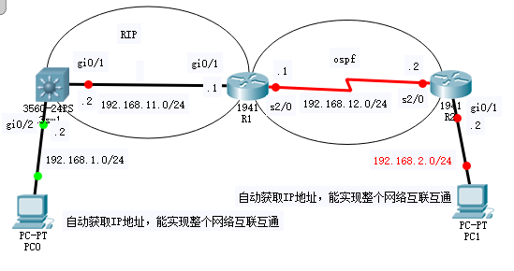
评分标准：
（1）网络设备连接正确，5分；
（2）标识正确，地址正确，5分；
（3）RIP配置正确，10分；
（4）OSPF配置正确，10分；
（5）DHCP配置正确，10分；
（6）路由重分发正确，10分。

交换机：
ip address 192.168.1.2 255.255.255.0
dhcp select relay
dhcp relay server-ip 192.168.12.2
#
interface Vlanif20
ip address 192.168.11.2 255.255.255.0
#
interface MEth0/0/1
#
interface GigabitEthernet0/0/1
port link-type access
port default vlan 20
#
interface GigabitEthernet0/0/2
port link-type access
port default vlan 10
#

（R1）：
#
sysname R1
#
interface GigabitEthernet0/0/0
ip address 192.168.11.1 255.255.255.0
#
interface GigabitEthernet0/0/1
ip address 192.168.12.1 255.255.255.0
#
interface GigabitEthernet0/0/2
#
interface NULL0
#
ospf 1
import-route rip 1
area 0.0.0.0
network 192.168.12.0 0.0.0.255
#
rip 1
undo summary
version 2
network 192.168.11.0
import-route ospf 1
#

（R2）：
#
sysname R2
#
snmp-agent local-engineid 800007DB03000000000000
snmp-agent
#
clock timezone China-Standard-Time minus 08:00:00
#
portal local-server load portalpage.zip
#
drop illegal-mac alarm
#
undo info-center enable
#
set cpu-usage threshold 80 restore 75
#
dhcp enable
#
ip pool lan1
gateway-list 192.168.1.2
network 192.168.1.0 mask 255.255.255.0
#
ip pool lan2
gateway-list 192.168.2.2
network 192.168.2.0 mask 255.255.255.0
#
interface GigabitEthernet0/0/0
ip address 192.168.12.2 255.255.255.0
dhcp select global
#
interface GigabitEthernet0/0/1
ip address 192.168.2.2 255.255.255.0
dhcp select global
#
ospf 1
area 0.0.0.0
network 192.168.2.0 0.0.0.255
network 192.168.12.0 0.0.0.255
#

